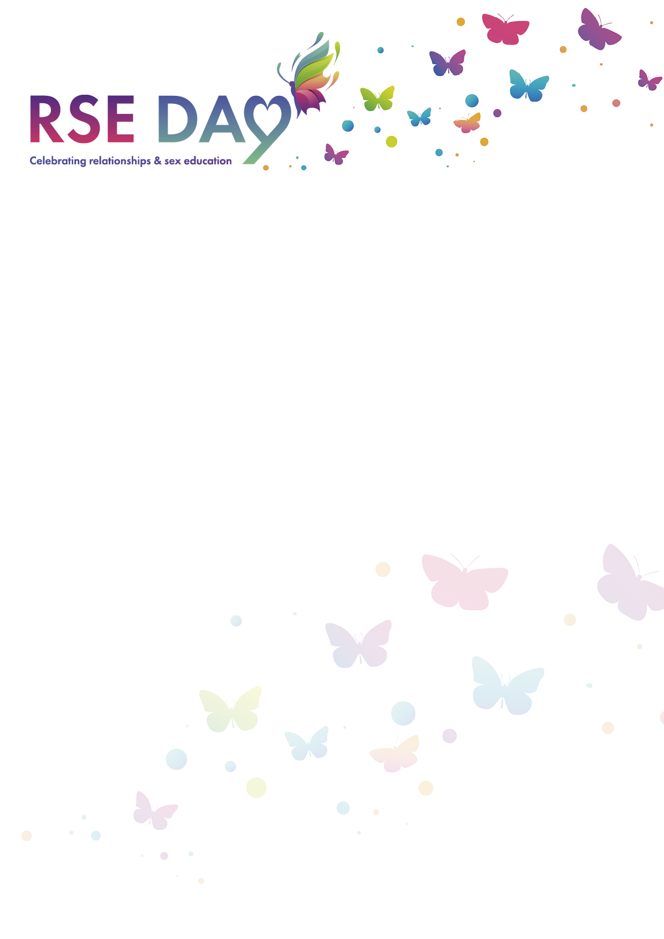

**Letter to My Future Self**

Imagine yourself in the future, a year from now. Think about all the amazing changes you have experienced and how you have grown. Now, it's time to write a letter to your future self, congratulating yourself on how you have embraced change. Use the space below to write your letter.

**Dear Future Me,**

*Start your letter here. Congratulate yourself on how you have embraced change. Think about specific instances where you faced something new or different and how you handled it.*

*End your letter with a closing message to your future self. You can use phrases like "With love," "Best wishes," or anything else you'd like.*