RSE Day Art Project 2024
‘Embracing Change’

About the project
The RSE Day Art Project is a collaboration between Nottingham City Council and ChalleNGe Nottingham which aims to support education staff to utilise creative techniques to explore Relationships and Sex Education (RSE) themes with children.
This year, we worked with artist Hannah Sawtell to explore the RSE Day 2024 theme of ‘Embracing Change’ through illustration. Hannah worked with children in two Nottingham schools, CP Riverside and Claremont Primary, to generate ideas for six postcards which schools could use in RSE lessons to stimulate discussion around change. The children produced some amazing art some of which is shown below.
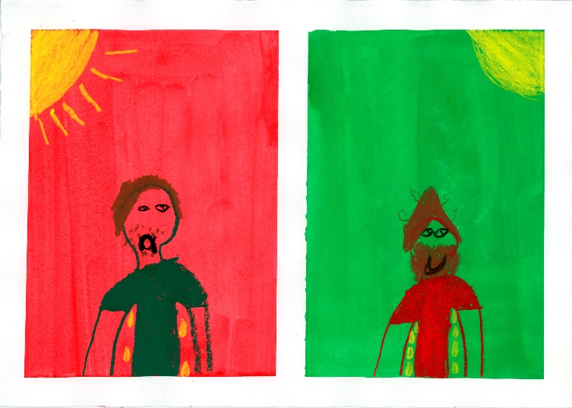
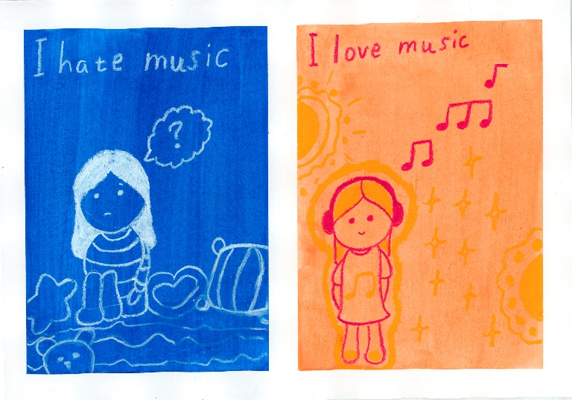
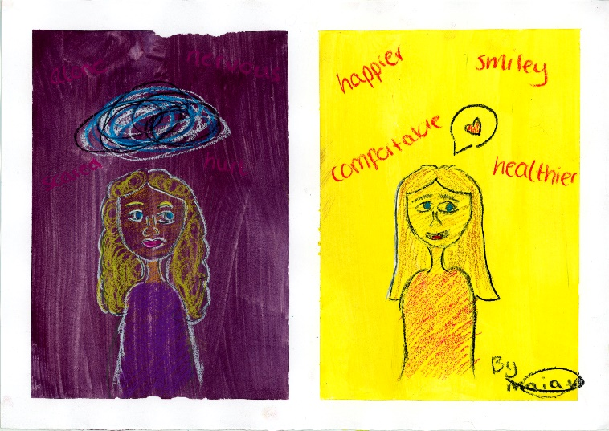
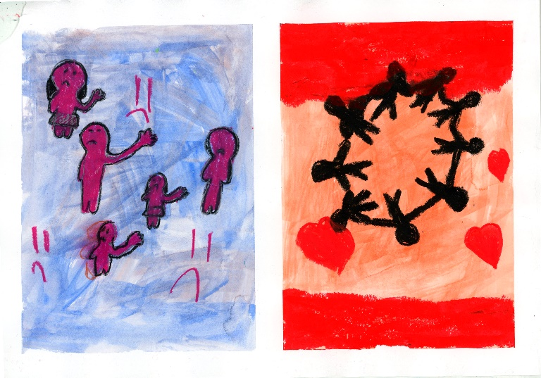

Hannah used the children’s art as inspiration when creating the final postcards. We are so grateful to the children at CP Riverside and Claremont Primary for their fantastic ideas. You can find out more about Hannah’s work here.

How to use the postcards
Each postcard on the pdf shows two pictures, before and after a change has occurred. The postcard images cover the broad themes of: changing families; changing homes; changing schools; changing minds; changing bodies; and, changing friendships.
Here are some ideas for using the postcard images to explore the theme of change:
- Split the class into groups, give each group a postcard, ask them to discuss the key questions: What change can you see? How could people feel about this change? How can people embrace change? Encourage each group to feedback their ideas to the whole class. Draw out the feelings associated with change and some key strategies for embracing change.

- Use the postcards as a stimulus for creative writing. Encourage the children to share how people feel about change through their writing.

- Prepare a sheet of A4 art paper with two boxes as shown in the examples above for each child (use masking tape to create the boxes). Using paints, ask children to create a colour wash base for each box. Lead a discussion on the types of change the children in your class may encounter. Share the postcards with the children and explore the artist’s style using Hannah’s website. Ask children to create their own illustration showing change. Display the children’s art in school and invite parents to view them. You can find a workshop plan and PowerPoint here.

- Split the class into groups, give one postcard to each group. Ask the children to create a piece of drama based on the scenario shown on their postcard. Share the drama pieces and explore feelings about change and strategies for embracing change.

We hope you enjoy using the original art on the postcards to explore the theme of ‘embracing change’ with your children. Huge thanks to the children at CP Riverside and Claremont Primary for their amazing art and ideas which inspired the postcards. We would also like to say a big thank you to Hannah Sawtell for her commitment and creativity.
For more information about RSE Day you can visit the website.
For more information about ChalleNGe Nottingham you can visit the website.

